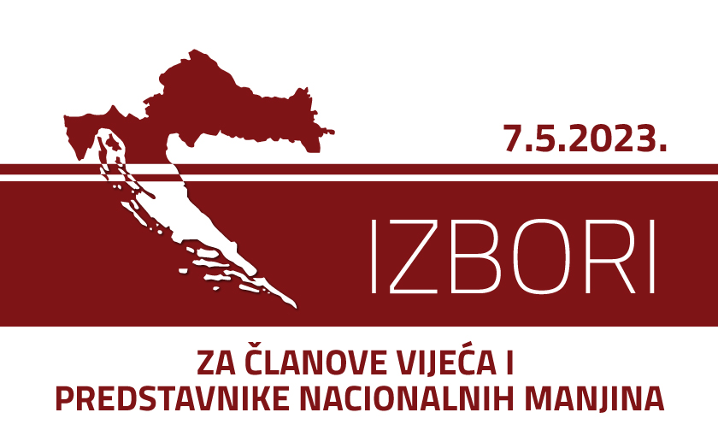

APPLICATION FOR ACCREDITATION AS AN INTERNATIONAL OBSERVER
OF THE 2023 ELECTIONS FOR COUNCIL MEMBERS AND REPRESENTATIVES
OF NATIONAL MINORITIES
To: Državno izborno povjerenstvo Republike Hrvatske
State Electoral Commission of the Republic od Croatia
Visoka 15, Zagreb, Croatia

dip@izbori.hr

OBSERVER'S INFORMATION

Observer's Name: ________________________________________________________
(last) (first) (middle)

Address: _______________________________________________________
(country) (postal code) (city) (street and no.)

Phone: E-mail:
___________________________________________________________________________

PASSPORT INFORMATION

Citizenship _________________________________Passport number_______________

Date of issue _________________________________ Expiry date _______________

Place of issue _______________________________________________________________

OBSERVER'S SPONSORING AUTHORITY

Name: ______________________________________________________________

Address: ______________________________________________________________

Phone: __________________________________ E-mail: _____________________

International Organization Non-Governmental Organization Other (please specify):

Government Regional Organization

___________________________________________________________________________
signature date

___________________________________________________________________________Accreditations can be collected at the State Electoral Commission of the Republic of Croatia, Visoka 15, Zagreb, phone number: + 385 (0)1 2100 600

